**Event Proposal**

**Innotek: Ideate-Implement-Innovate**

**Department:** Department of Student Research and Project

**Venue:** Stage 1 – At Individual School

Stage 2 – Innovation Studio

Stage 3 – Innovation Studio

**Introduction of Event:**

An inter-school competition is going to held in the campus of Lovely Professional University. Department of Student Research and Project –Division of Innovation and Entrepreneurship under the Student Welfare Wing presents Innotek: Ideate-Implement-Innovate.

The goal of the Innotek is to give students a platform to address some of the most serious issues that we encounter on a daily basis and to foster a culture of product innovation and a problem-solving mindset. In Innotek, students will also have the chance to work on some pressing problems of society, Govt./private sector organizations and are facing and develop world-class solutions for some of the biggest corporations in the world, assisting the private sector in hiring the brightest minds of the university.

**Important Dates**

|  |  |
| --- | --- |
| **Event Date** | **Dates** |
| **Call for Registration** | **18th Jan, 2023** |
| **Last Date of Registration** | **25th Jan, 2023** |
| **Idea Submission** | **29th Jan,2023** |
| **Announcement of Shortlisted Ideas** | **31st Jan,2023** |
| **Stage 1 :Idea Presentation(At Individual School Level)** | **3rd & 4th Feb, 2023** |
| **Announcement of Shortlisted ideas for Stage 2** | **5th Feb** |
| **Stage 2: Implement** | **March 10th, 2023** |
| **Shortlisted Ideas for Final Round** | **March 13th, 2023** |
| **Stage 3: Innovate - Grand Finale** | **March 28, 2023** |

**Event Structure**

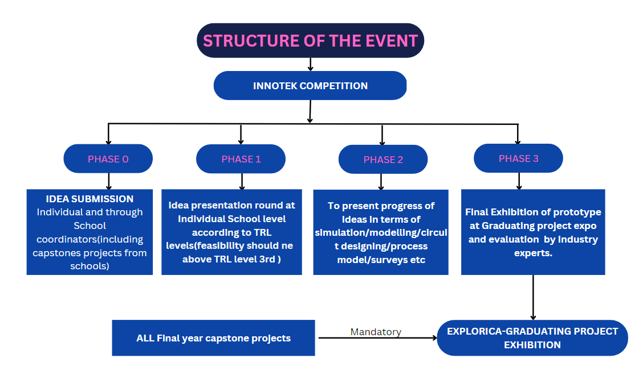

**Structure of event:**

The event will be conducted in 4 stages

**Stage 0: Idea Screening**

In this stage the submitted idea as per the format will be screened by Jury Member

**Stage 1 Idea presentation (Individual School level)**

In this stage the participants will submit their solutions to the problem statement of their choice from the pool of Themes.

**Stage 2 Implement**

The selected Ideas from Round 1 will participate in Stage 2 and present their progress of the Idea from Stage 1 which will include simulation/modelling/circuit designing/process model/surveys etc

**Stage 3 Prototype Presentation**

In the finale the student will present the working model of the idea and confirm the level of their reach from Ideate to Innovate.The prototype will be exhibited and evaluated at Explorica: Graduating project Expo.

Also all the Final Year Capstone Projects will be showcased in Explorica.

**Guidelines For Schools**

Minimum Entries required from schools are as follows:

i. Schools having strength greater than 1000 should have min 15 entries

ii. Schools having strength greater than 2000 should have min 30 entries

iii.Schools having strength greater than 4000 should have min 40 entries

iv.Schools having strength greater than 6000 should have min 60 entries.

Each School will carry out the Stage 1 in their respective blocks on the scheduled date

NOTE: It is mandatory for all the final year capstone project teams to participate in final project exhibition named as - EXPLORICA-GRADUATING PROJECT EXPO. Head of schools to take care for implementation of the same.

**Themes:**

* Agriculture and Rural development
* Clean and Portable Water
* Consumer Goods and Retail
* Defense and Security
* Education
* Fashion and Textile
* Finance and Life Sciences
* Food Processing/Nutrition/Biotech
* Healthcare & Biomedical Devices
* Infrastructure
* ICT, cyber-physical systems, Blockchain, Cognitive computing, Cloud computing, AI & ML.
* IoT based Technology
* Manufacturing
* Mining, Metals, Materials
* Other Emerging areas of Innovation For Startups
* Renewable and Affordable Energy
* Robotics and Drones
* Smart Cities
* Smart Textiles
* Smart Vehicles/ Electric vehicle/ Electric vehicle motor and battery technology.
* Software - Mobile App Development
* Software - Web App Development
* Sports & Fitness.
* Sustainable Environment
* Travel & Tourism.
* Waste Management/Waste to Wealth Creation

**Student benefits**

* Expect to be mentored by domain experts & industry specialists
* Create Position to get funded.
* Win Prizes worth Rs 10,000 along with Trophies and Certificates.
* E-certificates for all the Participants who have successfully crossed Stage 1
* Get a Chance to get Nominate from University for any National Innovation Convention

**Guidelines for Registration**

1. Minimum 3 and Maximum 5 members in team
2. Participant should submit their ideas as per Format circulated by us.
3. Interdisciplinary Teams are also allowed
4. Selected ideas from Idea Screening will go for the Stage 1 Presentation.
5. Stage 1 and Stage 2 will be in PowerPoint Presentation of Maximum 10 minutes of time.
6. Stage 2 presentation must comprises of Simulation/Ugly Prototype/3D modelling and Design/Circuit Design.
7. A single team cannot submit more than two ideas.
8. A participant cannot be a part of more than one team.
9. Stage 3, during Presentation full working Prototype is mandatory

**Guidelines for PPT**

Your PPT should preferably contain the following slides:

* Cover Slide
* Description of the Idea
* Technology Stack
* Feasibility
* Cost-Profit Analysis
* Estimated Showstoppers
* Innovation (how your product is different from the crowd?)
* In case of any technical difficulty, directly send the PPT by attachment to the organizer's email id.

**Prototype Guidelines**

* Projects should be original and based on new/innovative ideas and must have undergone some exploration and ground work to prove its feasibility and show impact.
* The Projects can be presented in the form of live demonstrations /models / posters/podium (oral) presentation in any aforementioned areas/fields.
* It should be fully working model/valid research outcome/field survey analysis
* Participants should bring all their requirements to execute their project.
* The organizers reserve the rights to change any or all of the above rules as they deem fit.

**Criteria for Assessment of Projects**

All the projects will be assessed on the basis of following criteria. Each criterion is

Assigned some weightage. The final selection of projects will be based on the

Cumulative weightage given on all criteria.

Criteria and Weightage

• Scientific Thoughts and Principles 20

• Creativity 20

• Relevance 20

• Scalability 10

• Skill 10

• Cost Effectiveness 10

• Teamwork 10

Apart from the above criteria, Scope of Commercialization of the projects will be

considered as an additional merit. However, there will be no weightage point for

this criterion. In case of the projects having scored equal cumulative waightage

point, this criterion will be considered for making the final decision

**Registration Link:** **https://tinyurl.com/Innotek-Comp**

**Submission of Idea for Stage 0 @ innovation.studio@lpu.co.in**